Make a fruit salad tree

How to cut and store scion wood to graft fruit onto a new tree
By Ellen Schindler

Imagine you tasted the best ever apple and you like it so much you want it in your own garden. Maybe you could buy the same apple tree - but what if you don’t know what type of apple it is or you cannot find it in a shop or garden centre?

Grafting is a way to re-create the tree that you tasted at your grandma or friend’s place. It allows you to clone your favourite trees, by taking a piece of a favourite existing tree and connecting it to another tree.

For apple trees the best time to cut and harvest the young branches (called scion wood) is July and the grafting is best done at the end of September. For plums and peaches the best grafting time is the end of August.

Grafting has to stay within the same fruit family to work. For example we know of the following fruit families that work well for grafting:
- All apple varieties
- All pear varieties (which include nashi and quince)
- All stone fruit (peaches, plums, apricots)

So while you can graft a variety of apple onto an apple tree, you could not graft it onto a pear tree or stone fruit tree. These fruit families like to stay together!

While it sounds intimidating, it is actually possible for anyone to harvest scion wood to use for grafting. In this step-by-step guide we will show you how!

There are also lots of good videos on grafting on Youtube or visit the Tree Cropper meeting, a fruit tree lovers group who meet monthly in many cities around NZ who will have experienced members who can share their grafting knowledge.

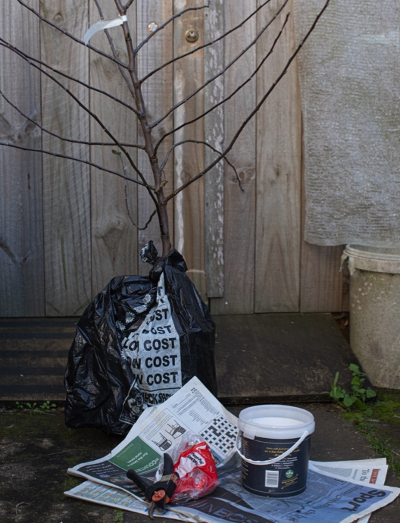
Gather your materials:

- A yummy apple tree that you want to clone and cut a graft from
- An apple tree in your garden or a pot that you want to graft onto
- secateurs or sharp knife
- moist newspaper (1-2 pages)
- 2 plastic bags, eg bread bags

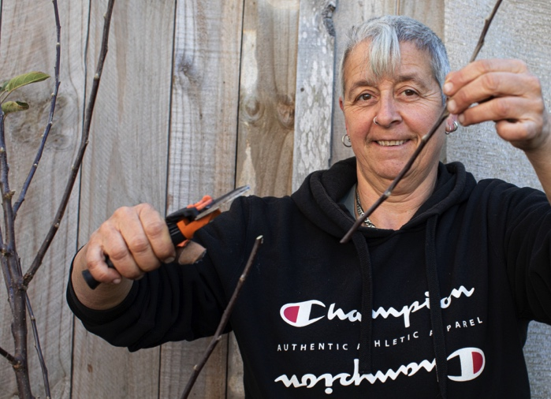
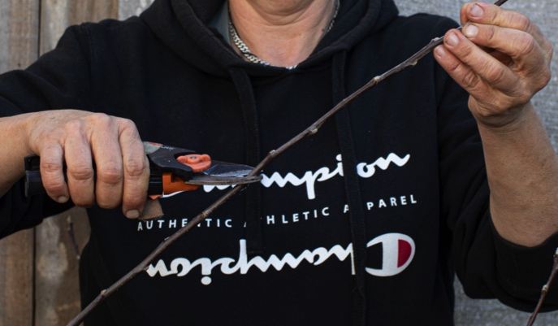
Harvest the scion wood:

- Cut a 10-20cm branch from the top of your favourite apple tree (about pencil thickness)

- This cut branch is your scion that will be grafted onto your new apple tree.

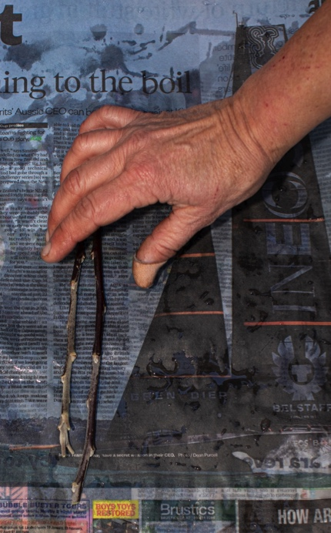
Prepare the scion wood for storage:

- As the scion wood is harvested a few months before it can be grafted onto a new tree it needs to be stored safely

- Moisten 1-2 pages of newspaper (not too wet) and wrap the scion pieces (branches) well and securely in it. The newspaper needs to be damp so the scion wood stays moits, but not so wet that it goes mouldy.

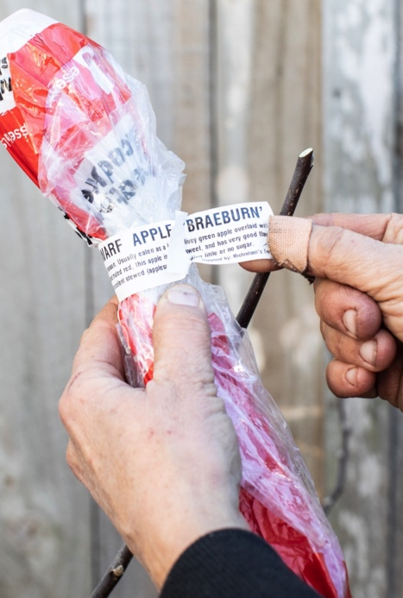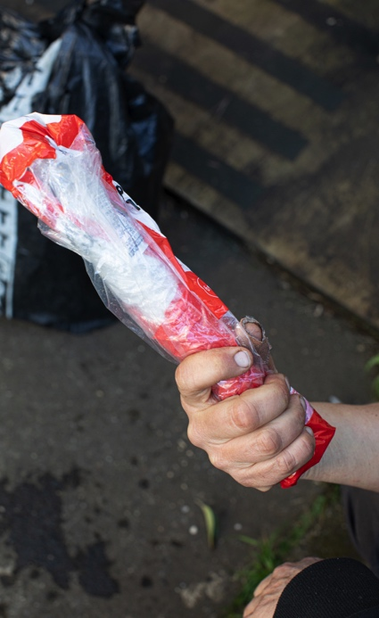
Safely store the scion wood until it is needed:

- Wrap the above package into a plastic bag and label (type of apple and date).

- Wrap in a second plastic bag and tie a band around it so it is well secured. This needed to prevent the scion wood from drying out.

- Store in the fridge until end of September

